What-If Analysis: Goal Seek

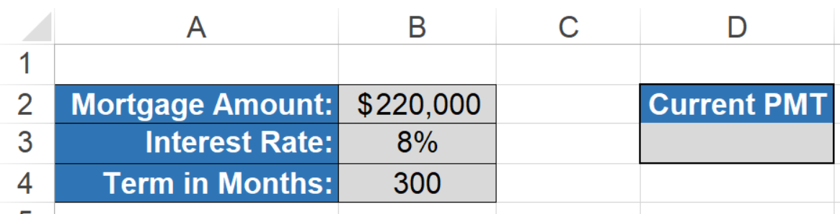

Question: If Target PMT is 1200, what will the interest rate be?

Current PMT = -PMT(B3/12,B4,B2)

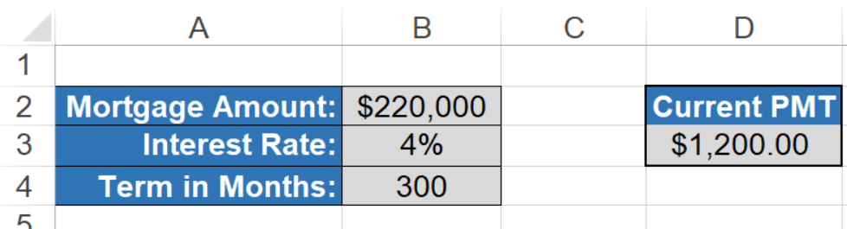

What-If Analysis: Solver Tool

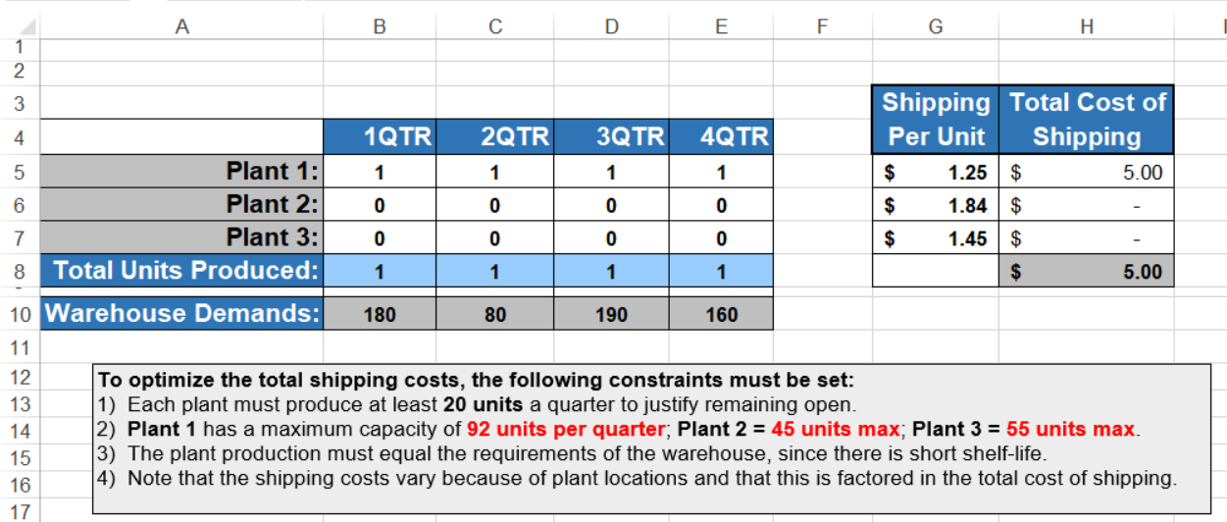

**Click**: Cell (to minimize) - Data - Solver

**Input**: Set Objective = Cell (to minimize) -To: Minimize - By changing Variable Cells: $B$5:$E$7

Subject to the Constraints: $B$5:$E$7 >= 20; $B$5:$E$5 <= 92; $B$6:$E$6 <= 45; $B$7:$E$7 <= 55; $B$8:$E$8; $B$10:$E$10

Total Shipping cost for H5=G5*(B5+C5+D5+E5)

Sum (Total Shipping cost) = H5 + H6 + H7

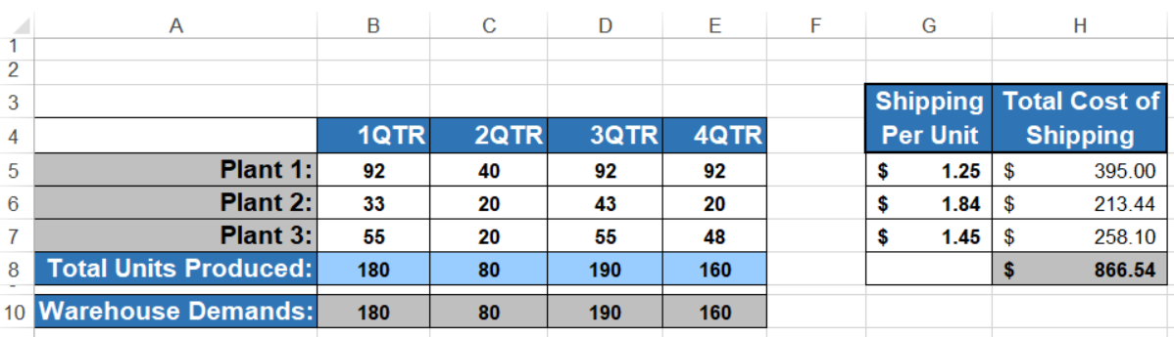

What-If Analysis: Data Tools

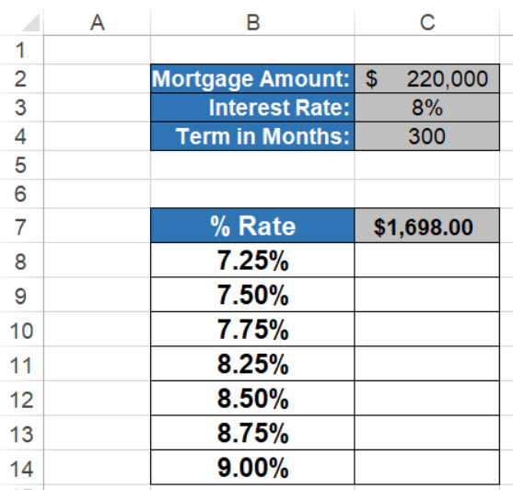

Question: For the respective Rate, how much is to be paid monthly?

@ 8 % rate = -PMT(C3/12,C4,C2)

**Click**: Highlight the Table () - What if analysis - Data Table

**Input**: Column input cell: $C$3 (i.e. =TABLE(,C3)); Output: @ 7.25% rate : $1,590.18 monthly pay

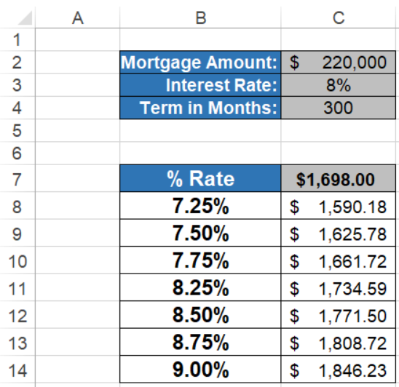

What-If Analysis: Scenario Manager

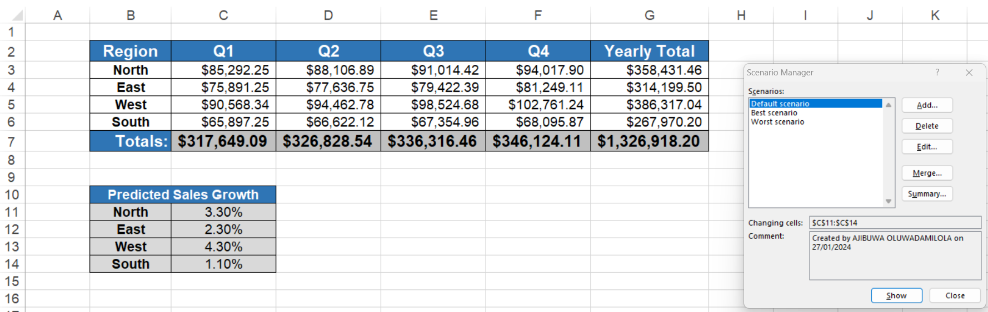

Prediction 1: Best case scenario

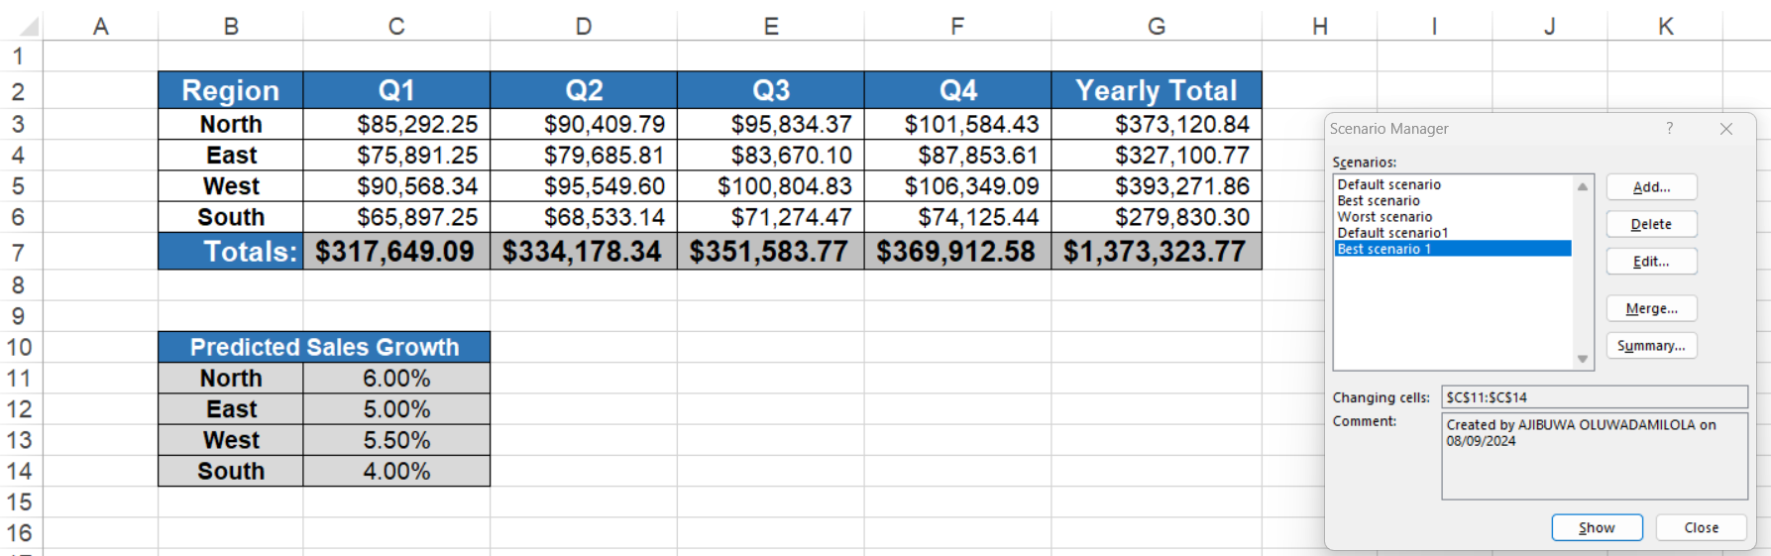

Prediction 2: Worst case scenario

